**Q2 CONCURRENT PROGRAM**

1. **REJECT DATA IF MOBILE NUMBER IS GREATER THAN 10 DIGITS;**
2. **TRANSFER M TO MALE**

**AND F TO FEMALE**

**CREATE A TEMPORARY TABLE RAJACOPY;**

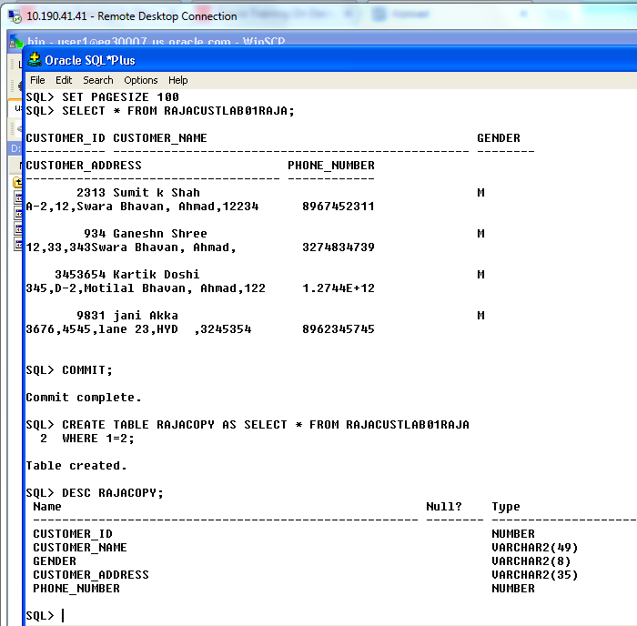

**CREATE A PACKAGE LOADERPACK_PKG;**

*CREATE OR REPLACE PACKAGE LOADERPACK_PKG*

*IS*

*FUNCTION VALIDATE_MOBILE_NUMBER*

*(P_CUSTOMER_ID RAJACUSTLAB01USERRAJA.CUSTOMER_ID%TYPE) RETURN CHAR;*

*FUNCTION GENDER_VALUE*

*(P_CUSTOMER_ID RAJACUSTLAB01USERRAJA.CUSTOMER_ID%TYPE) RETURN VARCHAR2;*

*PROCEDURE LOAD_RECORDS*

*(P_CUSTOMER_ID RAJACUSTLAB01USERRAJA.CUSTOMER_ID%TYPE,*

*P_CUSTOMER_NAME RAJACUSTLAB01USERRAJA.CUSTOMER_NAME%TYPE,*

*P_CUSTOMER_GENDER RAJACUSTLAB01USERRAJA.GENDER%TYPE,*

*P_ADDRESS RAJACUSTLAB01USERRAJA.CUSTOMER_ADDRESS%TYPE,*

*P_NUMBER RAJACUSTLAB01USERRAJA.PHONE_NUMBER%TYPE,*

*PROCEDURE PROC_LOAD(errbuff OUT VARCHAR2,RETCODE OUT VARCHAR2);*

*END LOADERPACK_PKG;***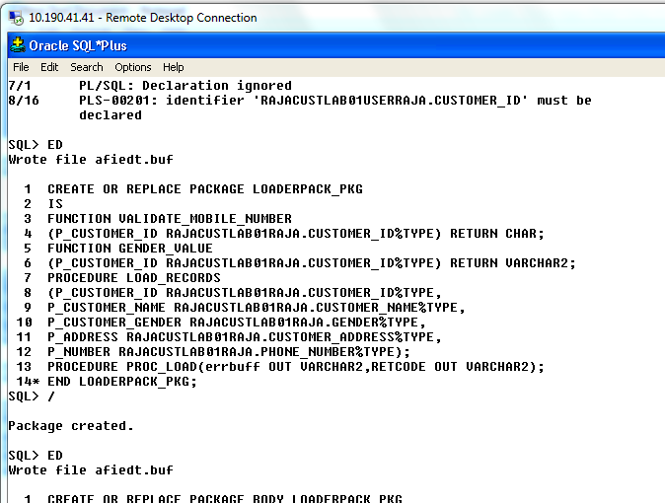**

**CREATE BODY FOR THE PACKAGE GIVEN ABOVE;**

*CREATE OR REPLACE PACKAGE BODY LOADERPACK_PKG*

*IS*

*FUNCTION VALIDATE_MOBILE_NUMBER(p_customer_id RAJACUSTLAB01RAJA.customer_id%TYPE) RETURN CHAR*

*IS*

*v_mobile_number NUMBER;*

*BEGIN*

*SELECT LENGTH(phone_number)*

*INTO v_mobile_number*

*FROM RAJACUSTLAB01RAJA*

*WHERE customer_id = p_customer_id;*

*IF v_mobile_number > 10 THEN*

*RETURN 'E';*

*END IF;*

*RETURN 'P';*

*END VALIDATE_MOBILE_NUMBER;*

*FUNCTION gender_value(p_customer_id RAJACUSTLAB01RAJA.customer_id%TYPE) RETURN VARCHAR2*

*IS*

*v_gender VARCHAR2(15);*

*BEGIN*

*SELECT gender*

*INTO v_gender*

*FROM RAJACUSTLAB01RAJA*

*WHERE customer_id = p_customer_id;*

*IF v_gender = 'M' THEN*

*RETURN 'Male';*

*ELSIF v_gender = 'F' THEN*

*RETURN 'Female';*

*END IF;*

*END gender_value;*

*PROCEDURE LOAD_RECORDS*

*(p_customer_id RAJACUSTLAB01RAJA.customer_id%TYPE,*

*p_customer_name RAJACUSTLAB01RAJA.customer_name%TYPE,*

*p_gender RAJACUSTLAB01RAJA.gender%TYPE,*

*p_address RAJACUSTLAB01RAJA.customer_address%TYPE,*

*p_number RAJACUSTLAB01RAJA.phone_number%TYPE)*

*IS*

*BEGIN*

*INSERT INTO RAJACOPY*

*(customer_id,*

*customer_name,*

*gender,*

*customer_address,*

*phone_number)*

*VALUES*

*(p_customer_id,*

*p_customer_name,*

*p_gender,*

*p_address,*

*p_number);*

*END LOAD_RECORDS;*

*PROCEDURE PROC_LOAD(errbuff OUT VARCHAR2,retcode OUT VARCHAR2)*

*IS*

*TYPE xxcustom09 IS TABLE OF RAJACUSTLAB01RAJA%ROWTYPE INDEX BY pls_integer;*

*xxcustom_09 xxcustom09;*

*v_g VARCHAR2(9);*

*v_m CHAR(1);*

*BEGIN*

*SELECT \**

*BULK COLLECT*

*INTO xxcustom_09*

*FROM RAJACUSTLAB01RAJA;*

*FOR i IN xxcustom_09.FIRST..xxcustom_09.LAST*

*LOOP*

*v_m:=validate_mobile_number(xxcustom_09(i).customer_id);*

*IF v_m = 'P' THEN*

*LOAD_RECORDS*

*(p_customer_id => xxcustom_09(i).customer_id,*

*p_customer_name => xxcustom_09(i).customer_name,*

*p_gender => gender_value(xxcustom_09(i).customer_id),*

*p_address => xxcustom_09(i).customer_address,*

*p_number => xxcustom_09(i).phone_number);*

*END IF;*

*END LOOP;*

*END PROC_LOAD;*

*END LOADERPACK_PKG;*

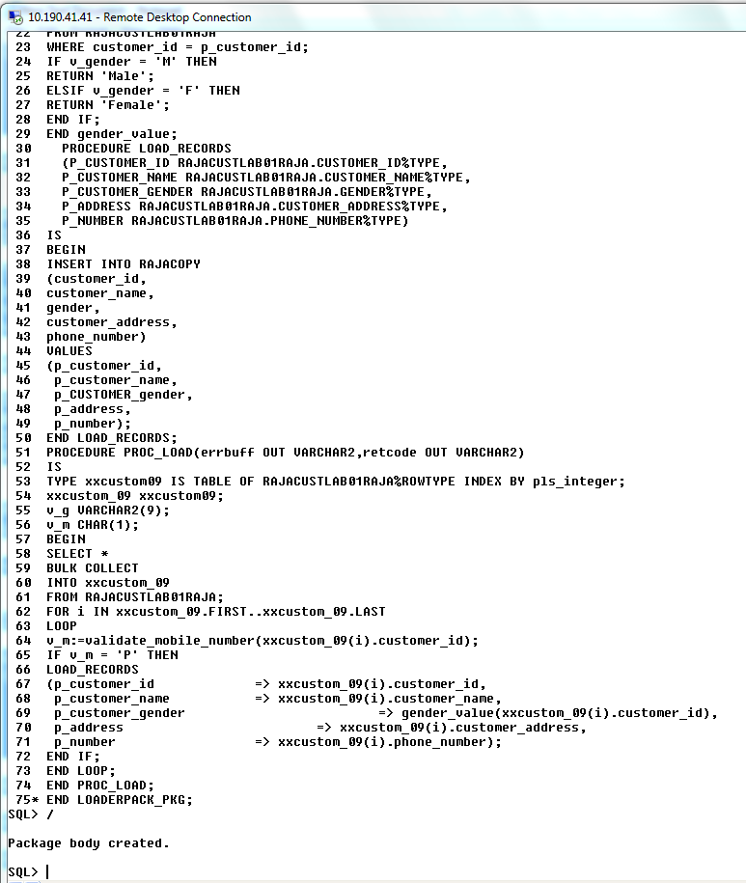

**CREATE A EXECUTABLE FILE FOR THE PACKAGE IN THE ORACLE SERVER**

**AND SAVE IT;**

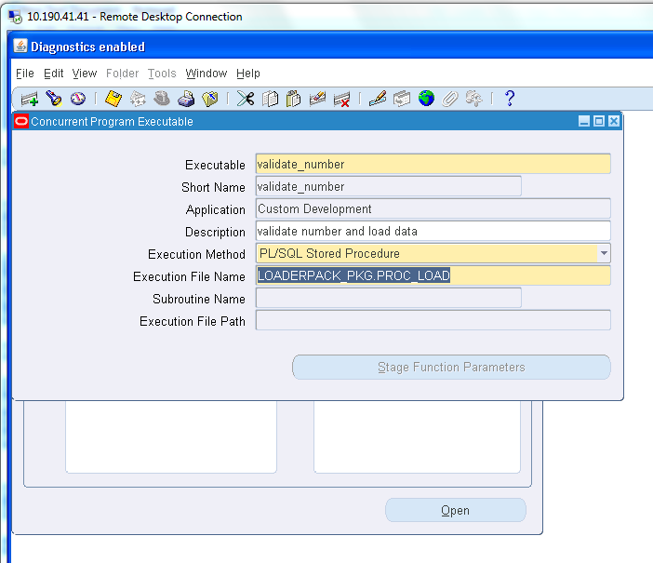

**CREATE A PROGRAM FILE FOR THE PACKAGE AND SAVE IT;**

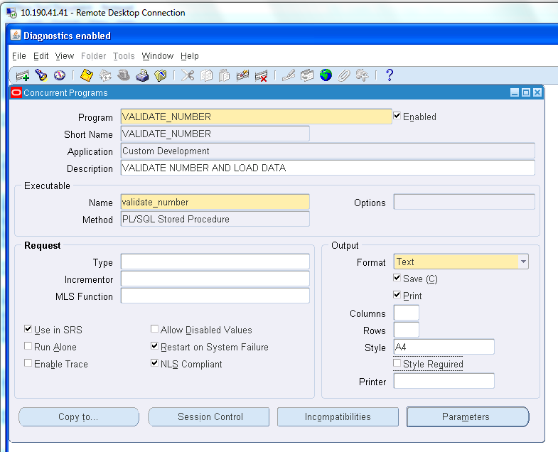

**PLACE IT IN THE GROUP AND SAVE IT;**

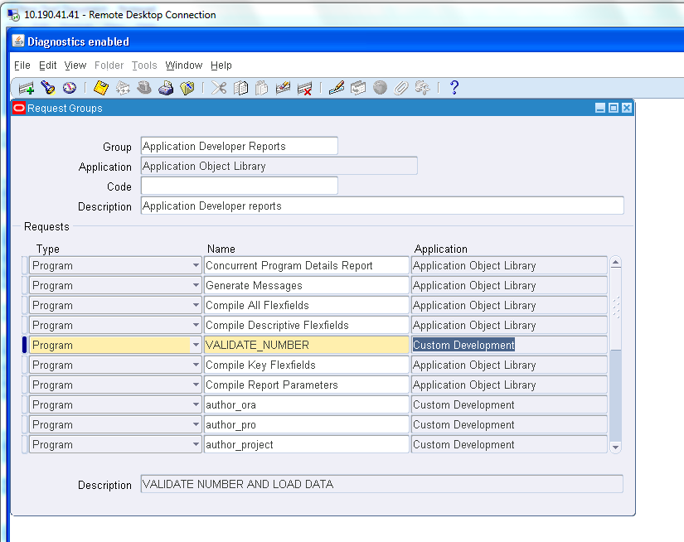

**RUN THE FORM**

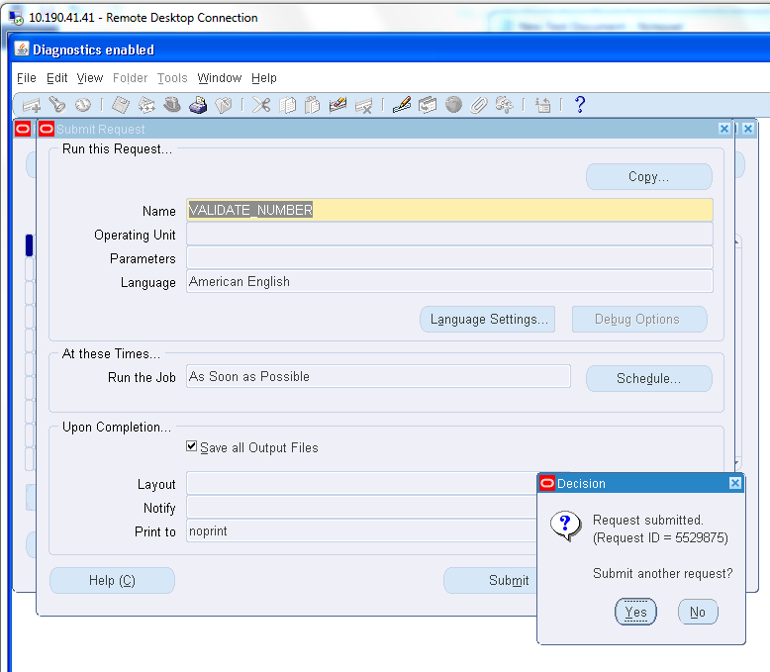

**CHECK OUTPUT FILE STATUS;**

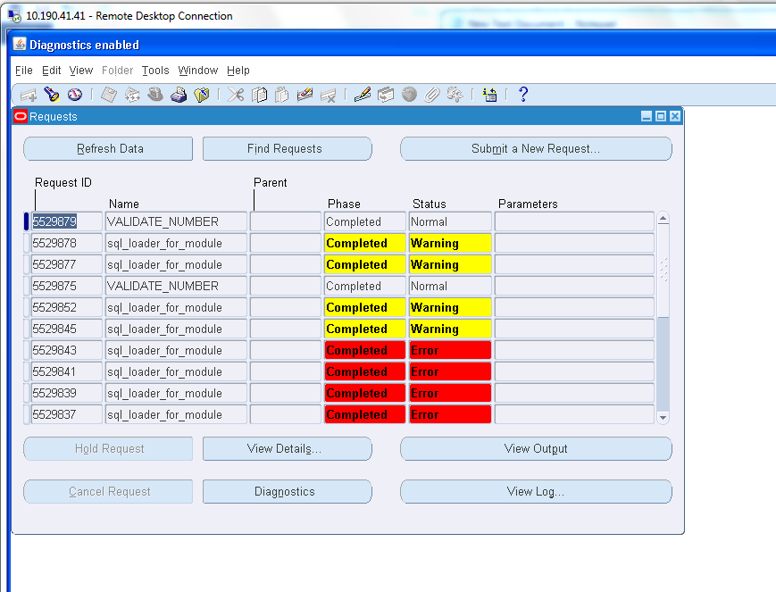

**CHECK OUTPUT FILE IN THE SQL PLUS**

**AND COMMIT CHANGES;**

